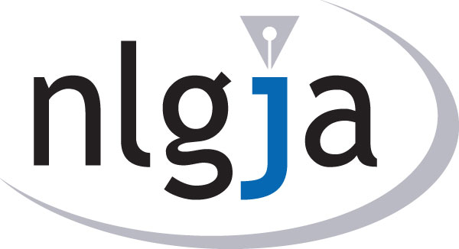
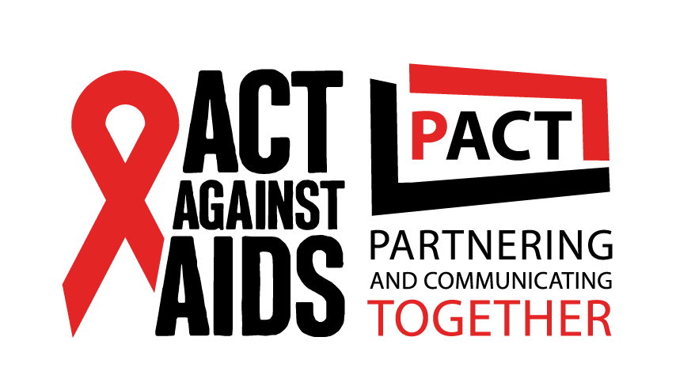
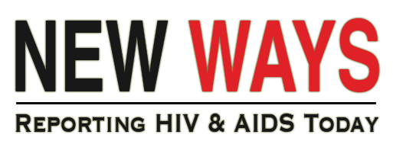

NLGJA Fellowship Program

NLGJA – The Association of LGBT Journalists and the Centers for Disease Control and Prevention Division of HIV/AIDS Prevention have established a strategic partnership to increase access to information on HIV and AIDS prevention, testing, treatment and stigma reduction. To help achieve the goal of getting the word out, especially to reach men who have sex with men, people of color and transgender Americans, NLGJA has launched a series of trainings and other resources for journalists as part of “New Ways: Reporting HIV & AIDS Today.” To further the reach, NLGJA has established three fellowships for working journalists.

Each of the three NLGJA Fellowships provides a $2,000 stipend for either:

Option 1. The production and publication/broadcast of three (3) mutually agreed upon articles/multimedia packages, each 600 to 1,200 words long or in 1- to 3-minute segments.

Option 2. The production of three video packages covering the topics covered during the NLGJA New Ways training seminars.

Fellows must agree to provide monthly updates and work with NLGJA in editing and fact checking prior to publication or broadcast. All work must be completed by September 30, 2016.

Qualifications:
- Demonstrated journalistic talent and coverage of HIV and AIDS prevention, testing, treatment and stigma reduction.
- Experience as a working journalist for a newspaper, news magazine, TV or radio station, news agency or online news outlet or as a freelance journalist or videographer.
- Experience covering or working with high-risk populations including men who have sex with men, people of color and the transgender community.

Application Requirements
- Cover letter describing your interest covering HIV and AIDS prevention, treatment, testing and stigma reduction, relevant experience covering these subject areas, experience reaching out to specified target populations that are particularly at risk, story ideas you’d like to explore with the support of a fellowship and your connections to get the stories published or broadcast
- Résumé
- Two samples of your work from the past year
- Letter of support from an editor or supervisor; if you are a freelancer, please provide a letter of support from someone who has edited, published or broadcast your work

Please email NewWays@nlgja.org with any question and to submit application materials for consideration. The application period will be open until all three fellowships have been awarded.

