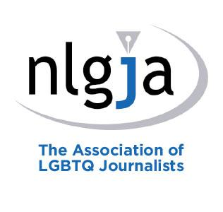
NLGJA - The Association of LGBTQ Journalists
Chapter Board Election Nominee Form
Deadline: July 28, 2017

This form has been created to compile candidates’ professional information more efficiently and quickly and to vet individual qualifications more effectively.

Nominees for NLGJA local offices – both new candidates and those planning to run for re-election – shall be required to submit this application detailing, among other things, their journalism and media experience, current employment status and a statement explaining why they are seeking office. The NLGJA Elections Chair and national office staff shall use the information to confirm the nominee’s membership status and eligibility for office. Upon request, non-confidential information in the application shall be made available to the voting membership.

Nominees must be current members in good standing for at least one year by the time of the election deadline.

Please note that the platform section will be used as your official statement that will be distributed to our voting membership.

Name:______________________________________________________________
Chapter affiliation:____________________________________________________
Home address:_______________________________________________________
E-mail address:_______________________________________________________
Day phone number:___________________________________________________
Evening phone number:________________________________________________

Which Chapter are you seeking a position in?

__________________________________________________________________________

What NLGJA office are you seeking?
Select one:
☐ Chapter Board Member
☐ ____________________________________ (Write-in Officer Title)

Your employer:
If you are self-employed or a freelancer, simply state “Self-employed” or “Freelance,” as well as your company name, if applicable.

__________________________________________________________________________

Your title/position:__________________________________________________________

Do you derive income from the gathering, editing or presentation of news or editorial content?
☐Yes
☐ No
Below or on an attached sheet, please supply a statement of why you wish to run for the position you seek. This will serve as your official “platform” that will be provided to our voting members. Your statement must not exceed 200 words.

The Election Nominee Form must be submitted by July 28, 2017 to:
David Steinberg, Elections Chair at elections@nlgja.org or the NLGJA National Office,
2120 L St. N.W., Suite 850, Washington, D.C. 20037.

All Chapter Board Members are required* to:
- Attend and participate in chapter board meetings.
- Maintain current membership in the organization.
- Be available to staff and chapter members.

*Some chapters may require additional duties from board members. Contact your local chapter leaders for more information.

By submitting this election nominee form, I understand and commit to the requirements of service as a member or officer on the NLGJA Board of Directors.

